The Economic Impact of
San Antonio’s Hospitality Industry
2021 Report

This study was prepared by:

Richard V. Butler, Ph.D.
Mary E. Stefl, Ph.D.
Trinity University

HIGHLIGHTS
- The 2021 economic impact of San Antonio’s Hospitality industry was $16.2 billion. This is considerably higher than the $13.9 billion observed in COVID-impacted 2020 and fully 93% of the 2019 pre-pandemic impact.

- The San Antonio metropolitan area attracted 31.7 million visitors in 2021.

- In 2021 the Hospitality Industry contributed some $229 million in taxes and fees to the city of San Antonio, and $528 million to all local governments combined.

- In 2021, the industry employed more than 128,000 individuals. This was 1 out of every 8 workers in the San Antonio metropolitan area.

- Total payroll in the industry was $3.5 billion, almost equaling the 2019 level of $3.6 billion. Since 2021 employment was only 88% of the 2019 total, it’s clear that average wages rose significantly.

- The economic impact of the Hospitality Industry in 2021 was more than double its size in 2001. Despite the challenges of the pandemic, the industry in 2021 was still bigger than it was in 2017.

INTRODUCTION

San Antonio has long been a premier meeting destination and is known as a favorite of visitors from around the world. These visitors, and the Hospitality Industry they support, produce a number of economic benefits for the city:

- The industry provides a large number of both full-time and part-time jobs in dozens of occupations, including culinary, customer service, administration, finance, maintenance, marketing, and human resources.

- Visitor spending impacts virtually every corner of the local economy – sports, food service, transportation, cultural events, healthcare and much more.

- The presence of so many visitors helps promote a vibrant and diverse cultural and social atmosphere that is attractive to San Antonio residents and visitors alike. Many of the amenities and attractions that San Antonians take for granted are available to them only because these attractions are also supported by millions of visitors.

- Because visitors bring new dollars to San Antonio, their spending has a multiplier effect. Each dollar of visitor spending generates approximately one additional dollar of income for San Antonio as the effects of this spending work their way through the local economy.

For the purposes of this report, the Hospitality Industry has been defined to include only those businesses that derive a significant portion of their sales from out-of-town visitors. Whether they come to San Antonio on a vacation, to attend a convention, or for business, these visitors patronize local companies that provide transportation and travel arrangements, lodging, recreational activities, and food and beverage services. Of course, the full economic impact of these businesses also includes their sales to local customers. A complete list of the industries included in this study can be found at the end of this report.

The economic impact analysis is based on data obtained from the Texas Workforce Commission (TWC). Following the same methodology used in the previous Economic Impact Studies of the Hospitality Industry, the current work is based on TWC’s quarterly wage and employment data aggregated along the lines of business defined by the North American Industrial Classification System (NAICS).

NOTE: This report normally measures the industry biennially in odd-numbered years. However, the past two years have been an extraordinary time. To show how the industry fared through the short-term trough and the steady recovery that has followed, 2020 data have been included in this year’s study.

THE HOSPITALITY INDUSTRY THROUGH THE PANDEMIC
AND BEYOND

The Hospitality industry everywhere faced challenging times in the era of COVID-19, and San Antonio was no exception. In 2019, the industry had a very good year, extending the long-term trend of steady growth over the past three decades. Starting in March of 2020, the economic environment became much more challenging. Even so, millions of visitors came to San Antonio in a year when travel demand was greatly reduced. The rebound that started in mid-2020 continued through 2021.

Tens of Millions of Visitors

Each year – even in the midst of a pandemic -- tens of millions of visitors come to San Antonio for business or pleasure.

- In 2019, 41 million visitors came to the San Antonio metropolitan area.

- In 2020, San Antonio hosted 23 million visitors.

- In 2021, the visitor count increased to nearly 32 million.

- Each year, millions of leisure visitors come to San Antonio to shop, play, and enjoy the city’s unique history and culture. In 2019, the San Antonio metropolitan area hosted 33.9 million leisure visitors. In 2020, 19.7 million leisure visitors came to San Antonio. In 2021, that volume increased to 27.1 million leisure visitors

- San Antonio has long been one of the top convention cities in the country. In 2019, 7.1 million business visitors came to the area for conventions and other business purposes. Of course, business and convention travel throughout the country was greatly reduced during the pandemic. Still, in 2020, 3.3 million business visitors came to San Antonio, and that number rose 40% to 4.6 million in 2021.

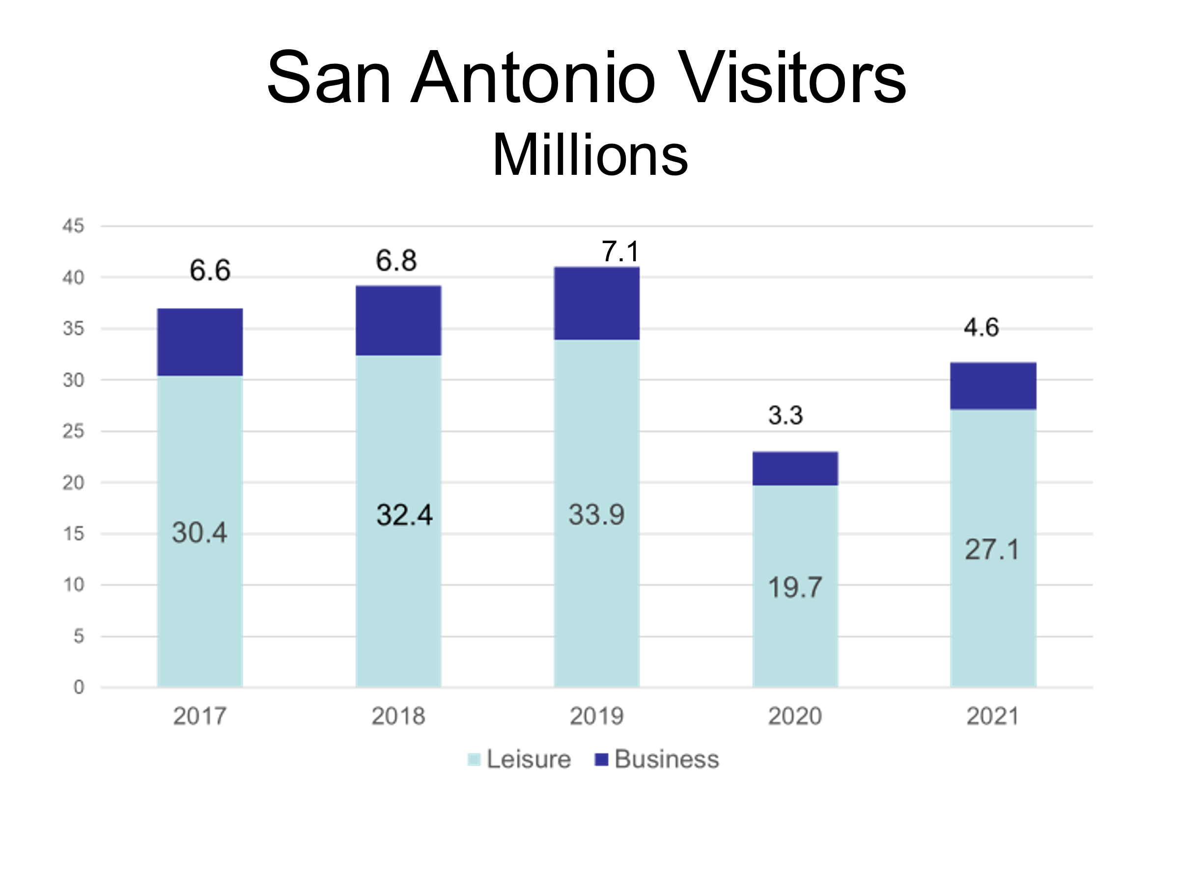Overall Economic Impact: almost back to the 2019 level

The Hospitality Industry’s economic impact in 2021 was $16.2 billion, 93% of the 2019 impact. The pandemic’s effects notwithstanding, this represents a 3% increase over 2017 and a 33% increase over 2011. Hospitality is still one of the largest industries in San Antonio.

The businesses that make up the Hospitality Industry fall into four sectors: Transportation and Travel Arrangements, Lodging and other Traveler Accommodations, Restaurants and other eating and drinking establishments, and
Entertainment and Recreation activities, ranging from golfing establishments to cultural events to amusement parks and spectator sports.

The Restaurants and Catering sector made the largest contribution to the local economy in 2021, accounting for more than half of the industry’s total economic impact. Indeed, the $8.8 billion impact of restaurants in 2021 is greater than their $8.4 billion impact in 2019. Over the past three years, the share of economic impact due to restaurants has grown from 48.5% to 54.4%. The vast majority of this large impact was due to full-service or limited-service restaurants and eating places, with the remainder coming from catering services and drinking establishments.

The Transportation and Lodging sectors contributed 15.8% and 17.4% respectively to the overall economic impact in 2021. Entertainment of various types comprised the remaining 12.4% of the industry’s economic impact.
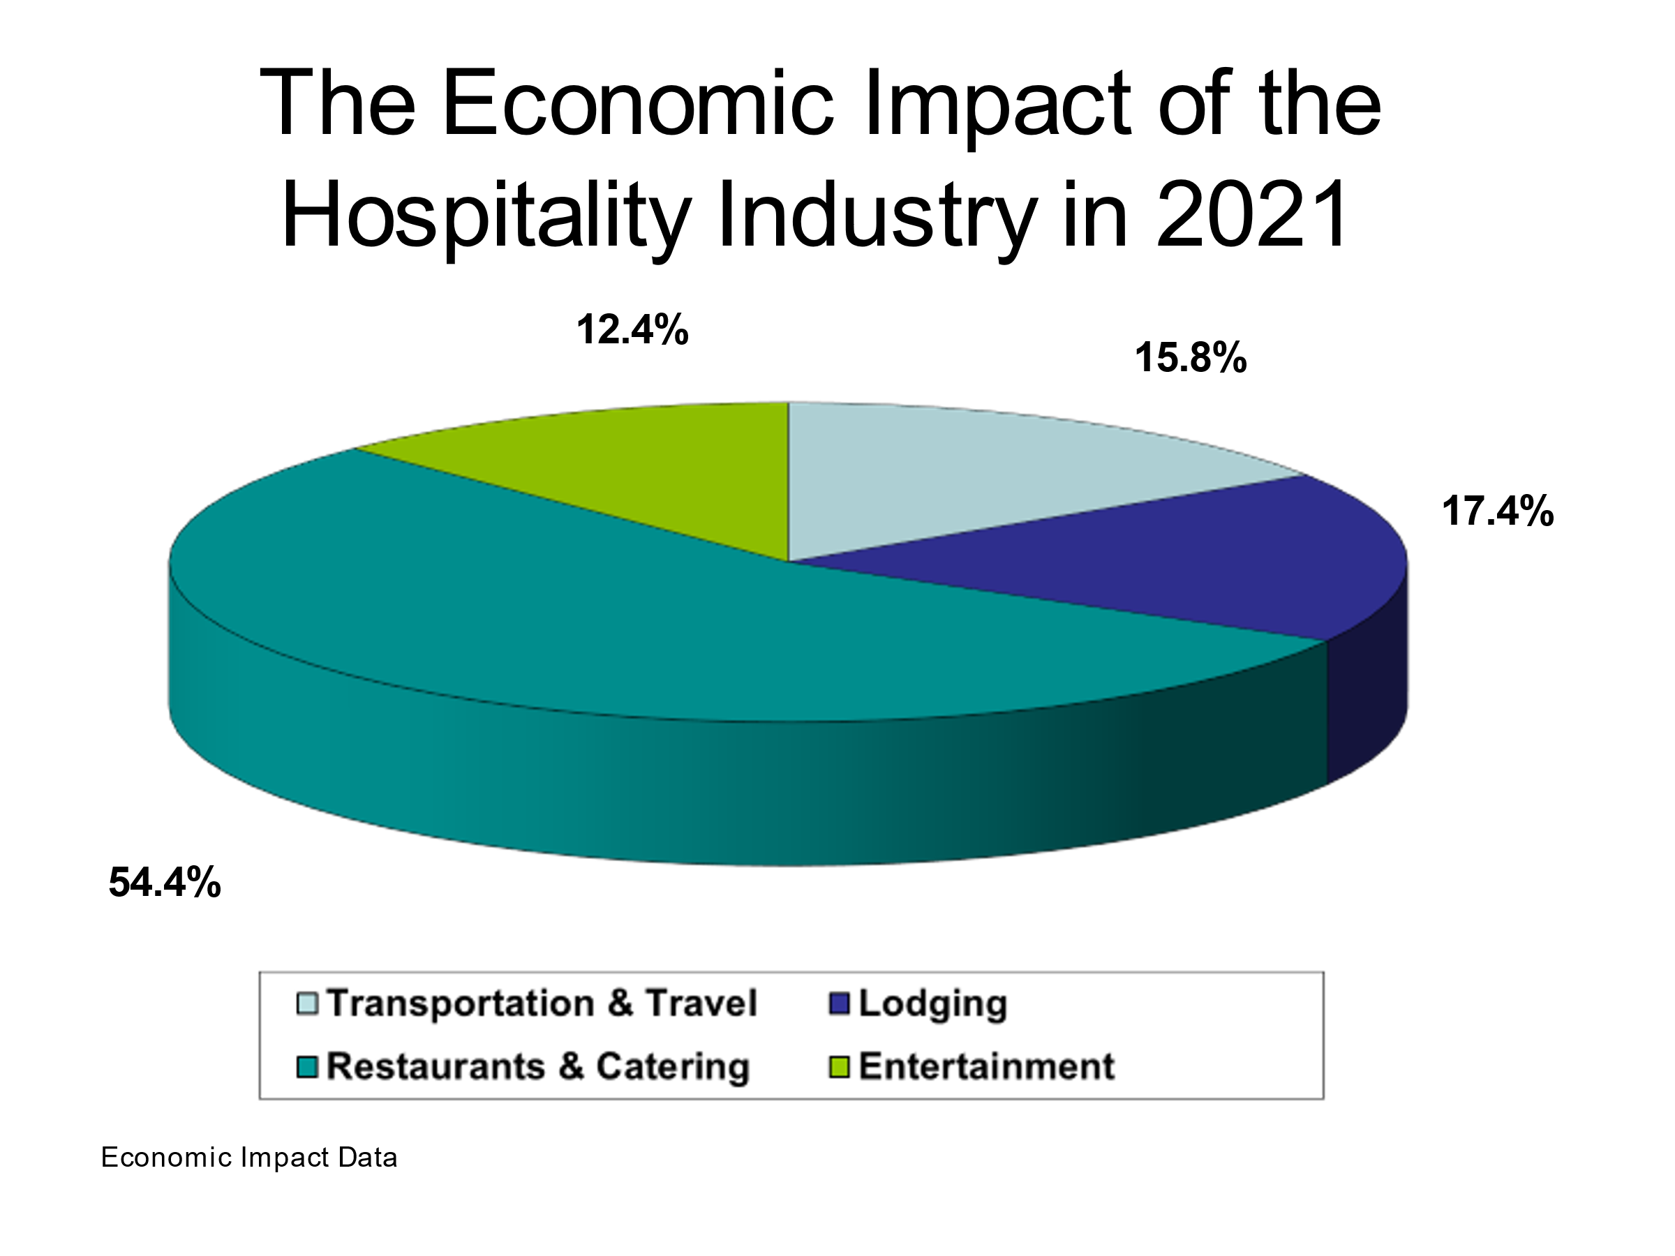
Annual Payroll: $3.56 Billion in 2019, $2.95 Billion in 2020, $3.49 billion in 2021

The Hospitality Industry’s annual payroll was $3.56 billion in 2019, up 20% from 2017. The $2.95 figure for 2020 was still larger than the industry’s payroll from 2015. Total payroll recovered almost to the 2019 level by 2021.

It should be noted that these figures reflect only direct wage payments. Total compensation, including benefits and gratuities, would be significantly higher.

Total Employment: 145,056 in 2019, 117,270 in 2020, 128,062 in 2021

During 2019, the Hospitality Industry provided an estimated 145,056 jobs represents one-seventh of the total number of jobs in the San Antonio metropolitan area. Despite a 19% drop in employment for 2020, the industry still employed 11.9% of San Antonio’s jobs. Employment rose by nearly 11,000 in 2021 but is still well below the 2019 level

Many of these jobs provide life-long career opportunities and help employees develop skills that translate into many areas of business. This

Putting 2020 into perspective

The economic impact, wages and payroll in the Hospitality industry dropped substantially in 2020 as the pandemic took hold. The effects of the pandemic on travel and entertainment started near the end of the first quarter of 2020. Indeed, 2019 was another year of the steady growth the industry has experienced over the past two decades, and the first quarter of 2020 was right in line with that. However, the second quarter of 2020 witnessed a steep drop in employment and wages across the industry, especially in the lodging and entertainment sectors. The third and fourth quarters illustrate the resilience of the industry, especially in the restaurant sector in which employment rebounded to within 10% of the first quarter level by year's end. There was also a modest uptick in the lodging sector, though it and the entertainment sector remained well below their first-quarter benchmarks for employment and wages. This recovery continued into 2021, with steady gains in payroll and employment.
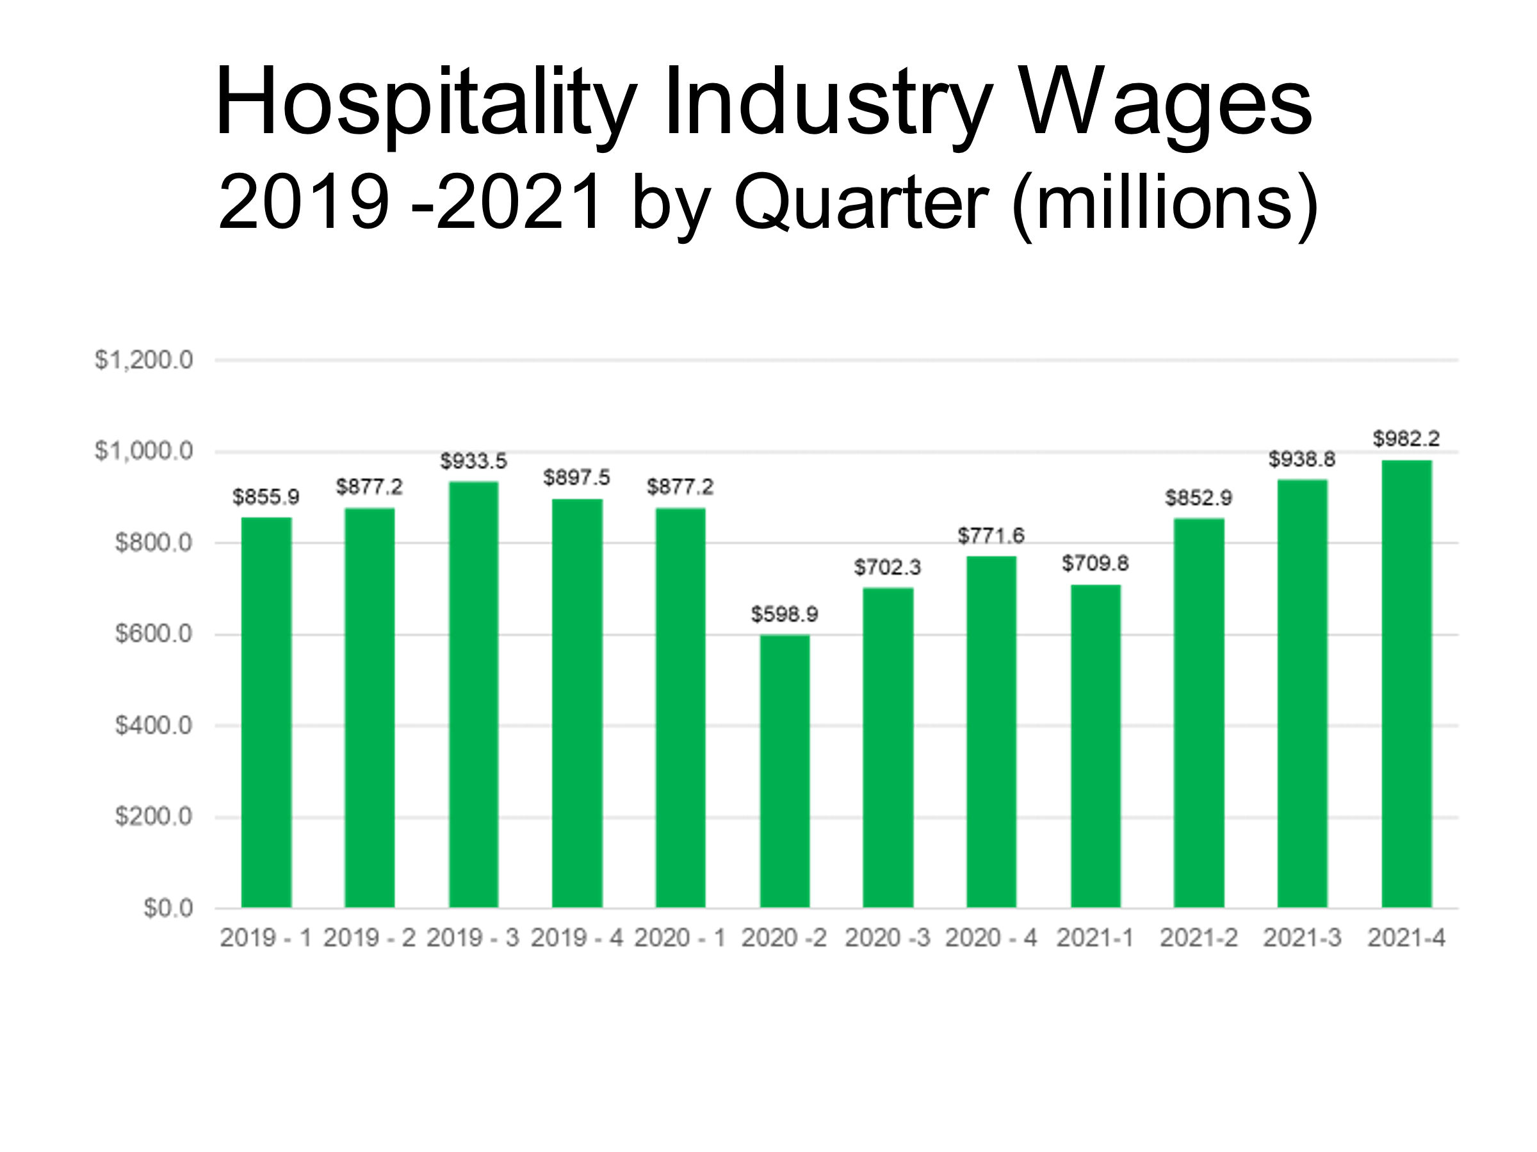
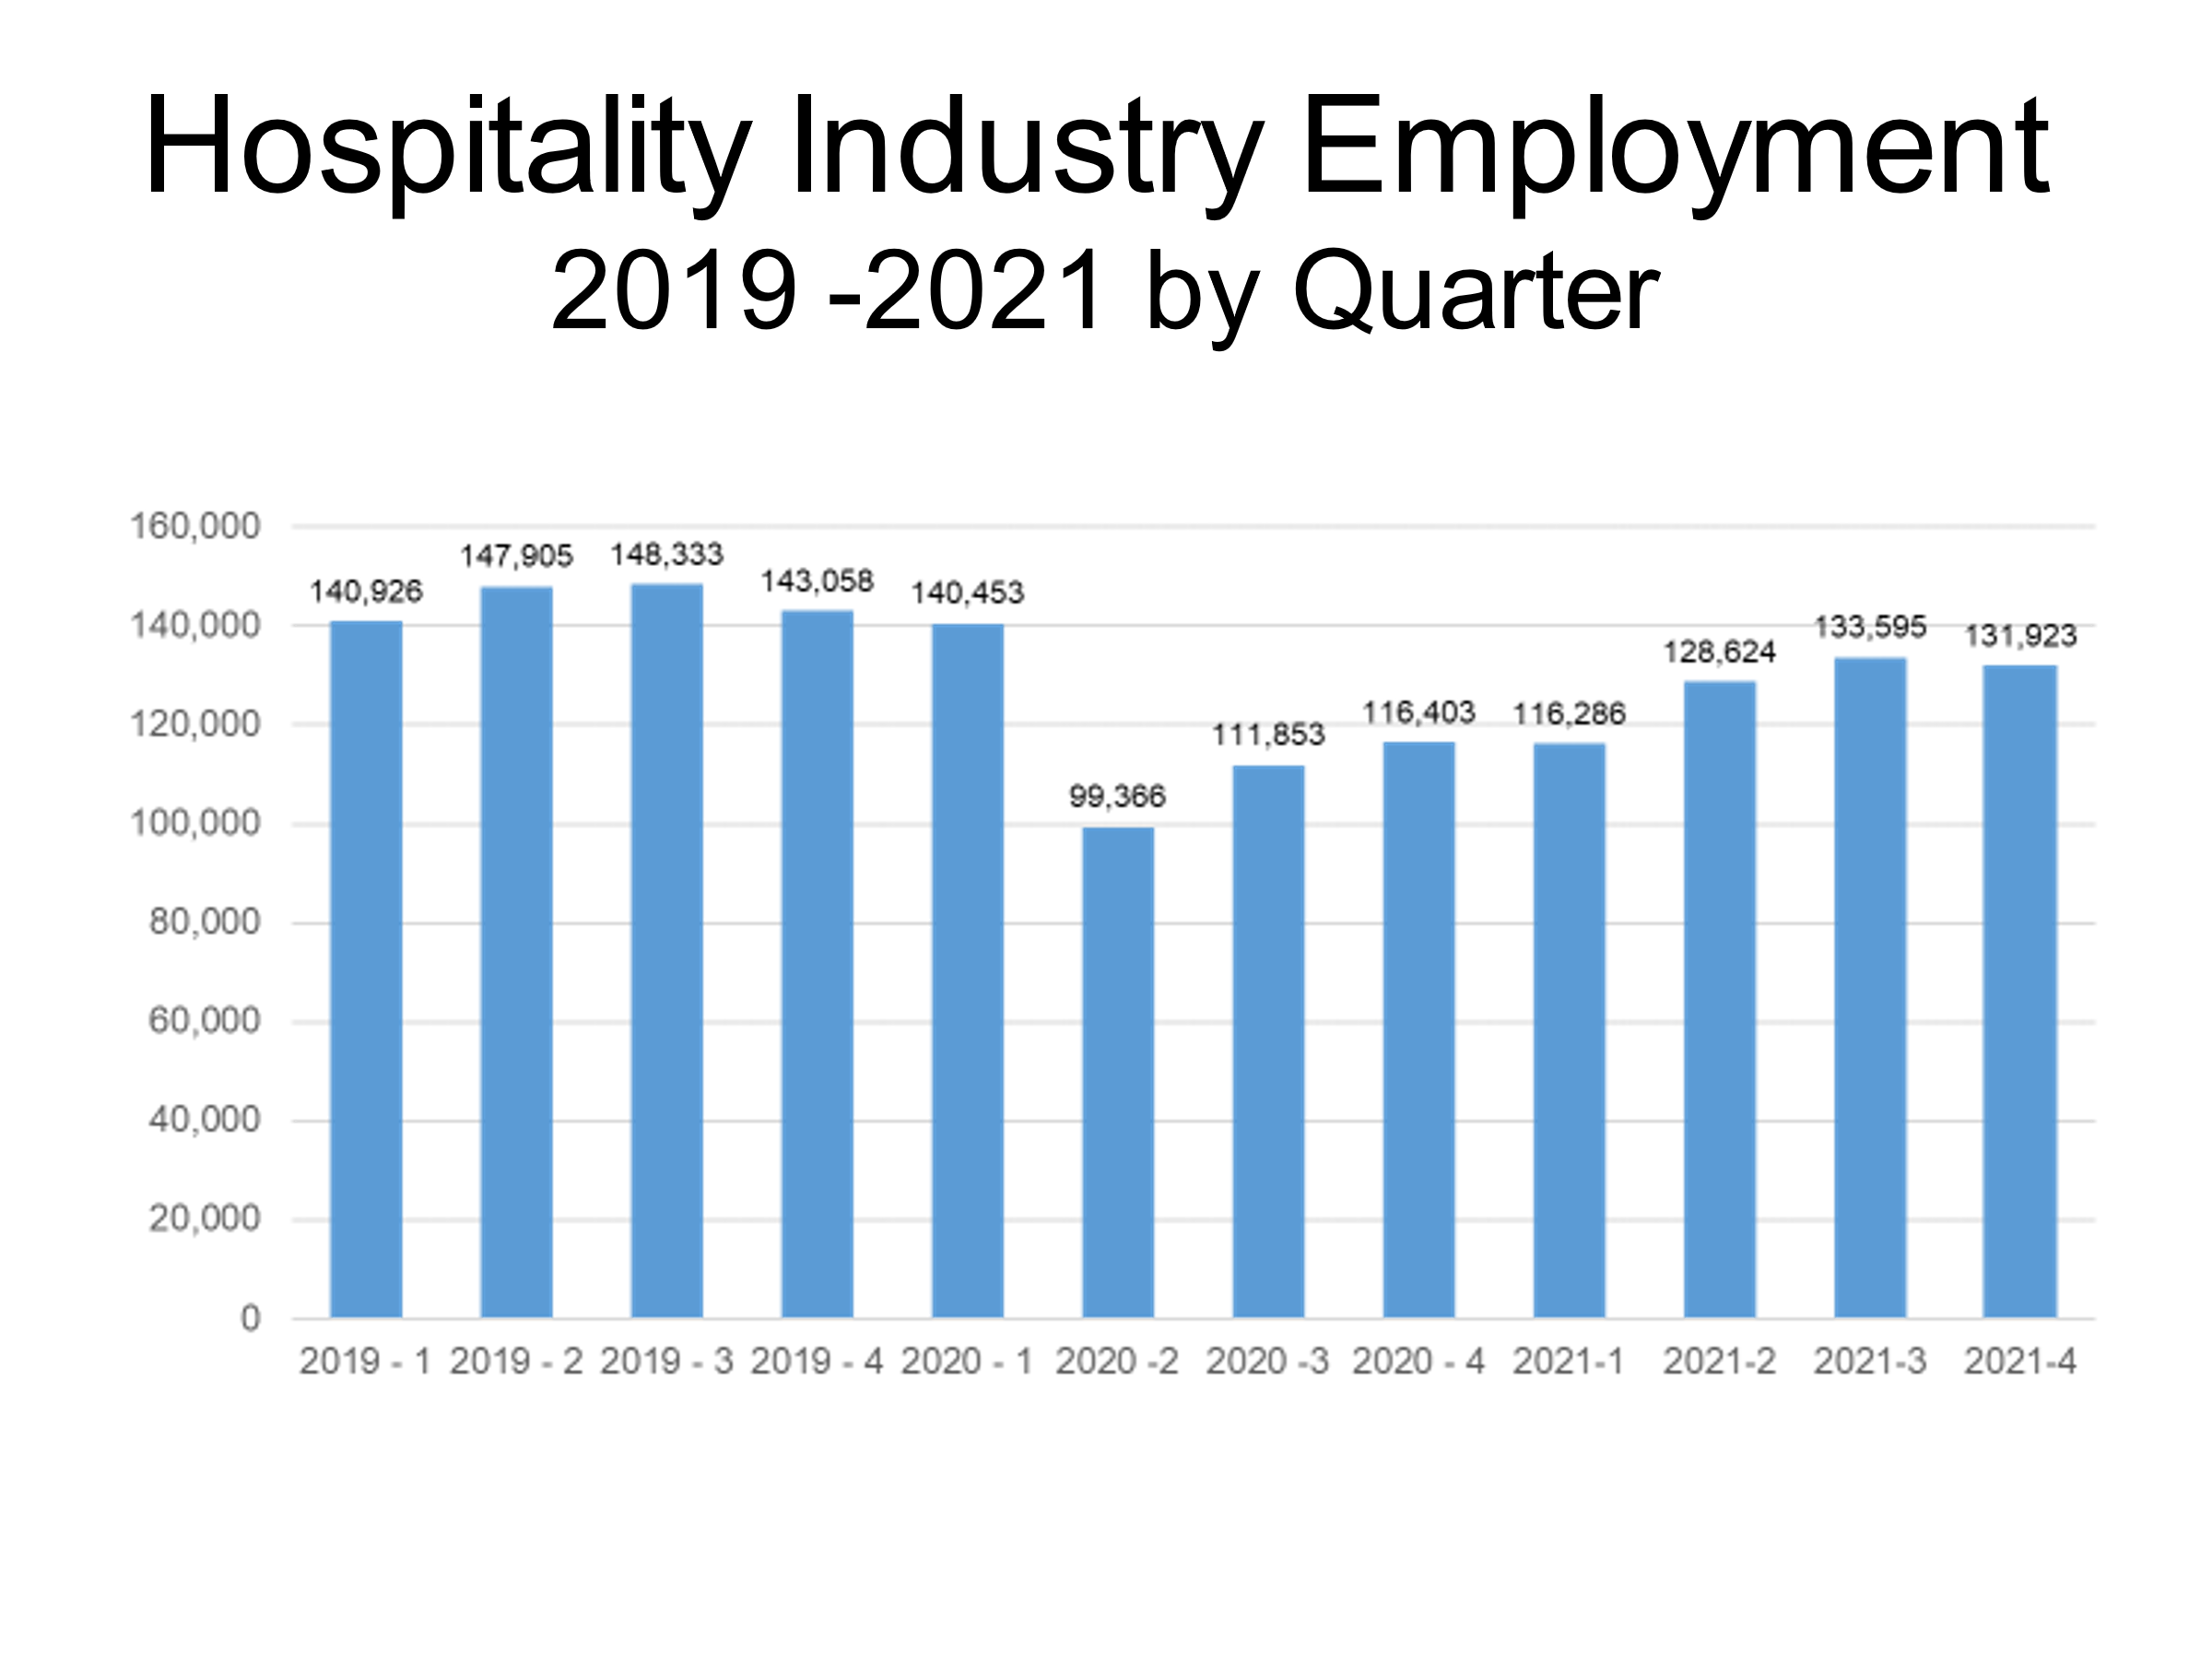

THE HOSPITALITY INDUSTRY OVER TIME

From 2011 to 2019, the Hospitality Industry’s economic impact grew substantially, from $12.2 billion in 2011 to $17.4 billion in 2019 – a 43% increase. The growth over a longer time horizon is even more impressive: a 118% gain from the $8 billion impact the industry had in 2001. What is especially striking is that the industry grew steadily over two decades despite challenging national economic conditions during much of that period. The 17% increase in impact from 2020 to 2021 suggests that this long-term trend has already resumed. It is a great advantage for San Antonio to have as one of its major industries one that is so resilient over the business cycle.

NOTE: The numbers reported in this study are based on the latest available data. Since data for prior years is often updated by the reporting agencies, the amounts reported here may differ slightly from the amounts appearing in previous reports.

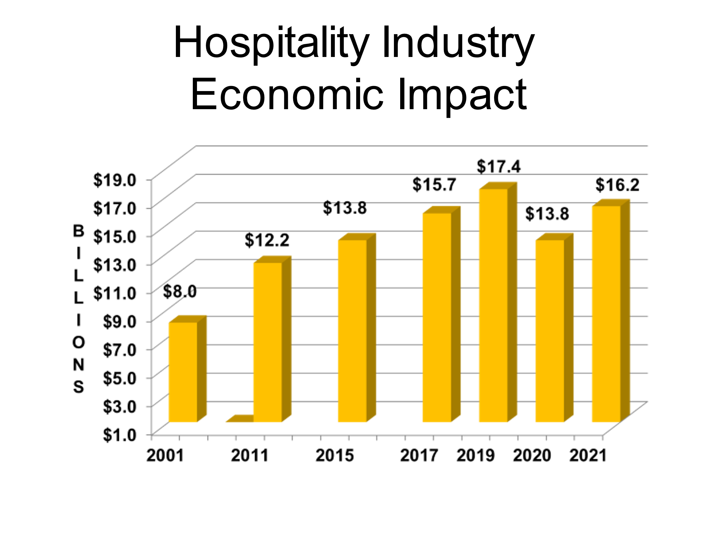

The number of employees in the industry has also grown, as the graph below indicates. Employment increased by 29% between 2011 and 2019. After a significant dip during the pandemic year of 2020, the number of employees increased by 9% in 2021.

The slower rebound in employment reflects much broader trends in the industry nationally as many employers modified the manner in which services were rendered. For much of 2020, for example, housekeeping staff did not perform daily cleaning in many hotels. Many restaurants initiated or enhanced carryout or delivery services. At the same time, hourly wages increased as employers have attempted to rebuild their workforce. Thus, some of the industry’s recovery from the pandemic may not be reflected in the number of employees.

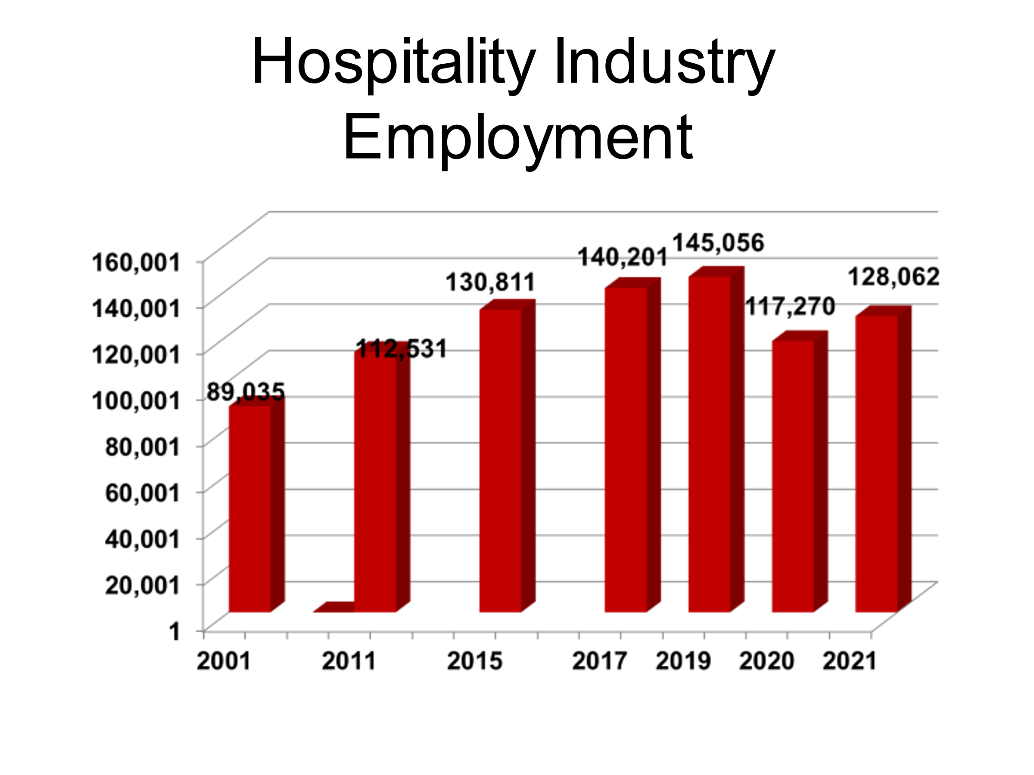Total wages in the industry have grown much more briskly. They increased by 64% from 2011 to 2019, and by 157% from 2001 to 2019. Wages in 2021 are almost identical to those in 2019. Combined with the slower growth in employment since 2019, it’s fair to say that average compensation has increased significantly.

Note that this wage data significantly understates employee compensation. It includes only salary, not including benefits, and it does not include the tips received by the many tipped employees in the hospitality industry.

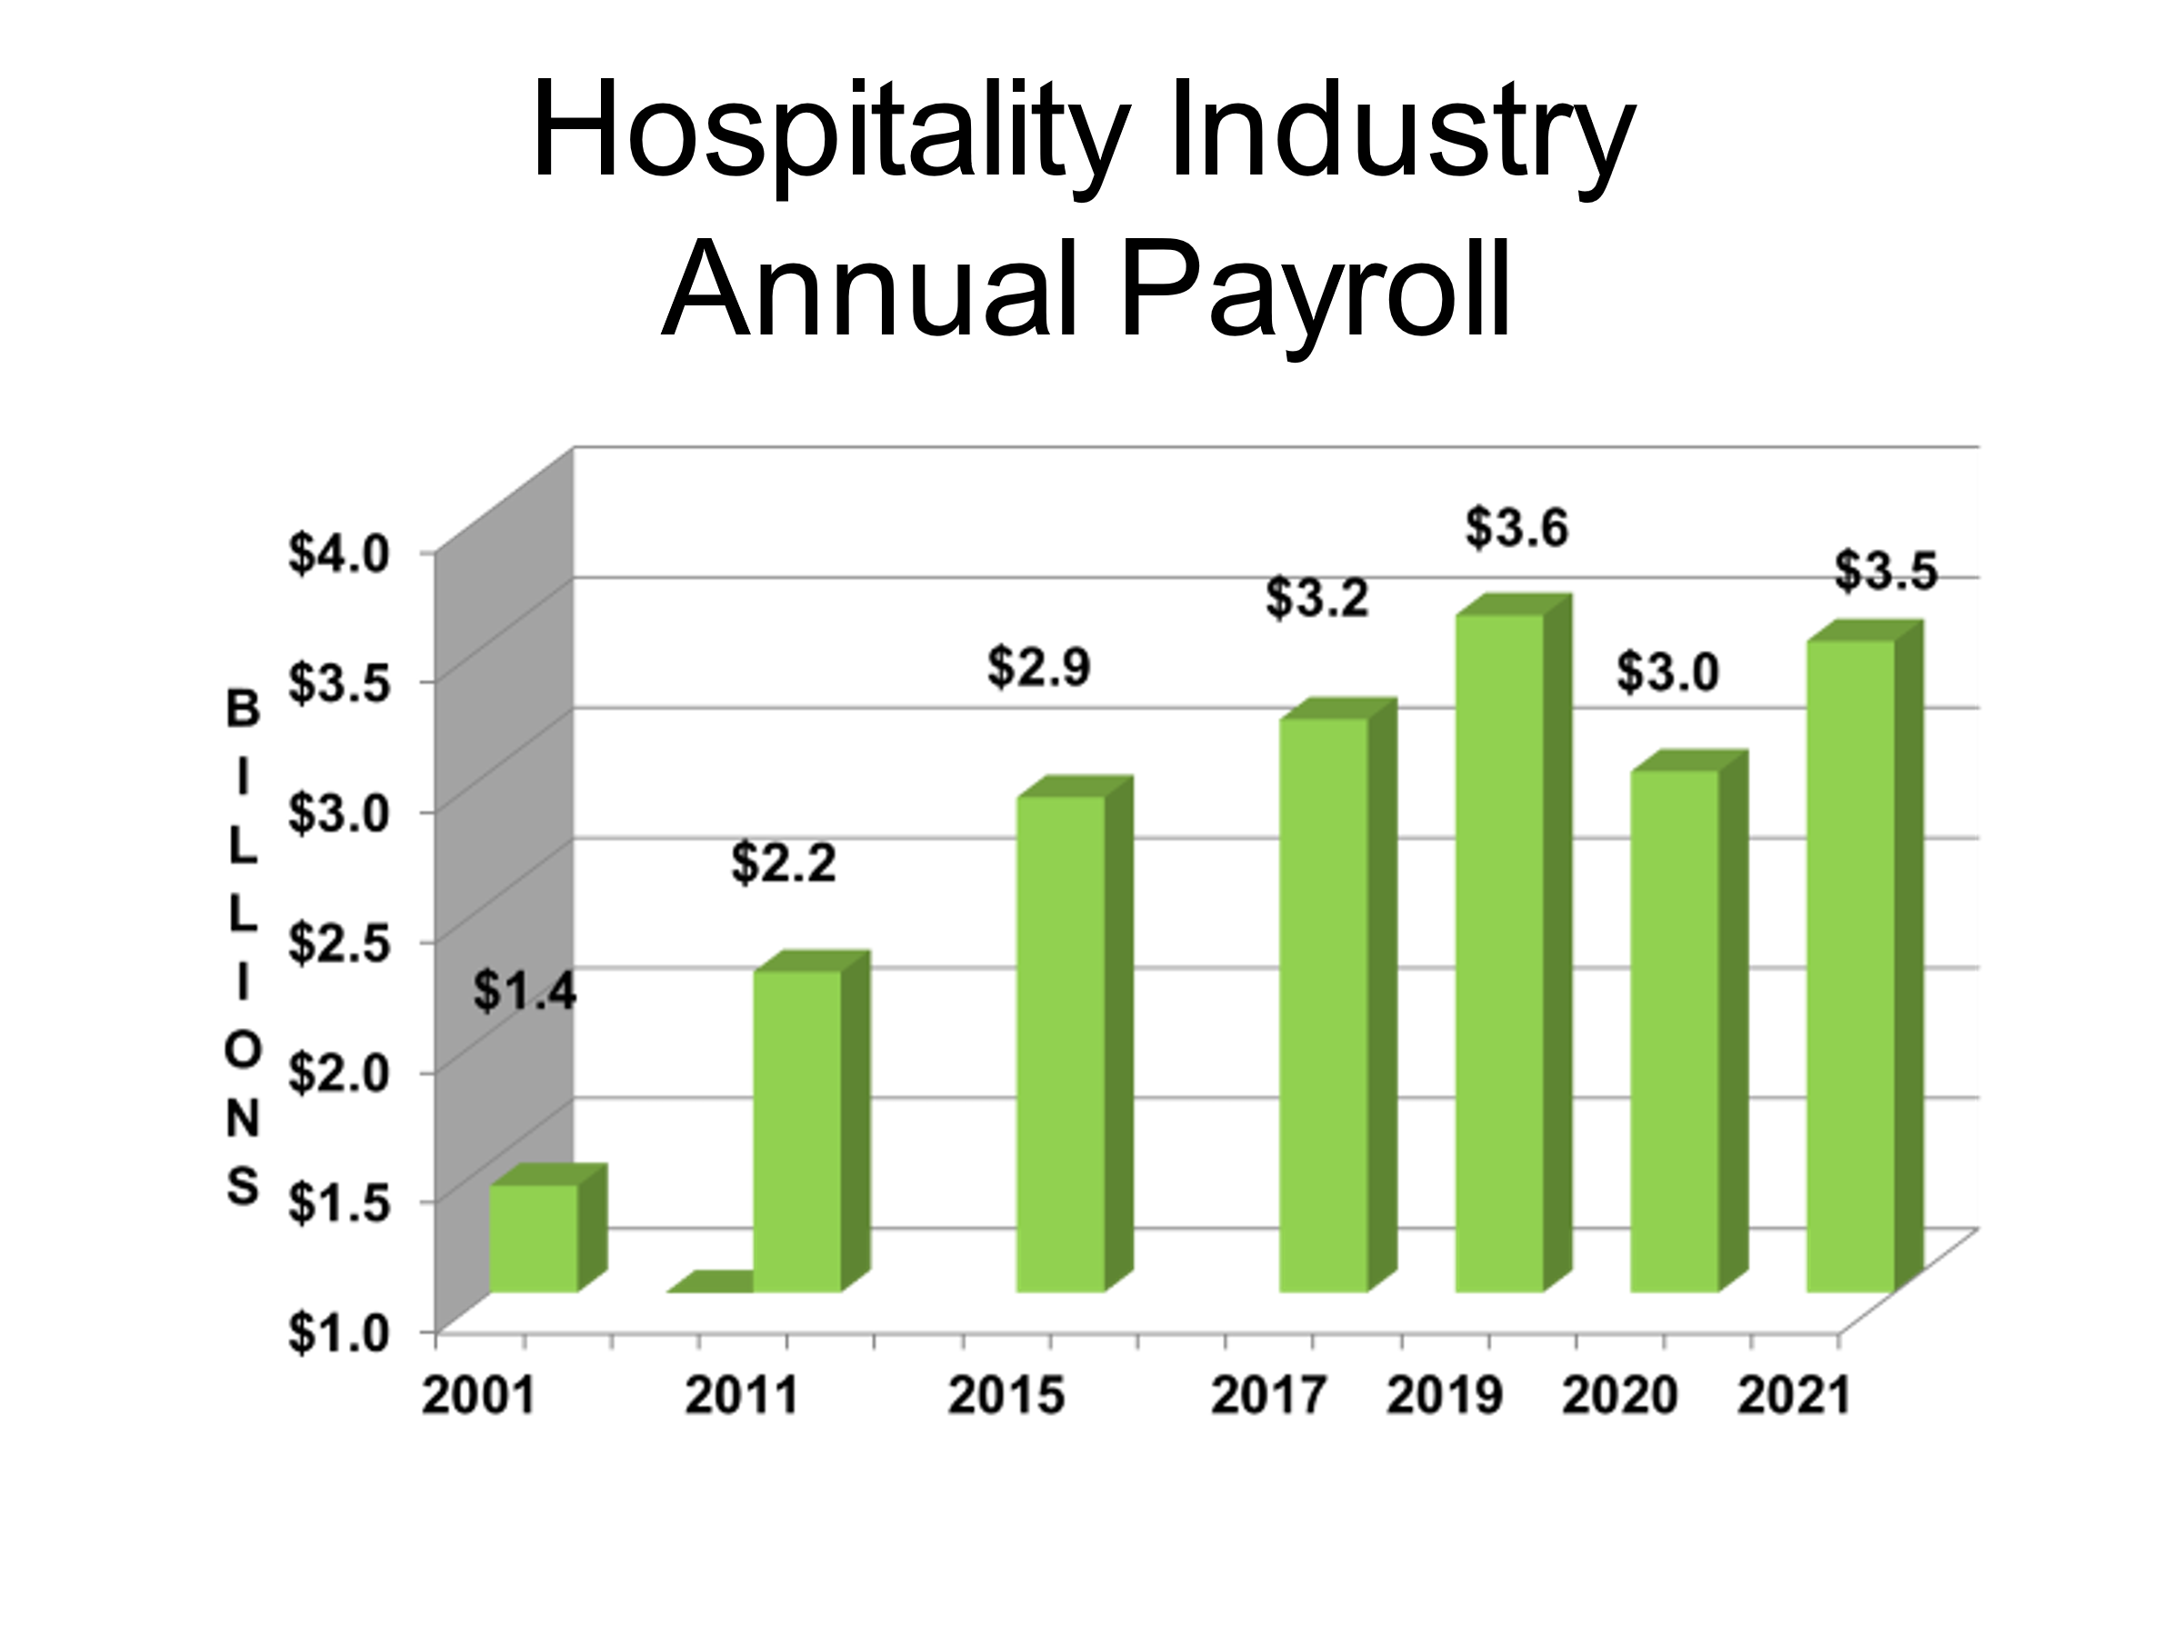

Over the past ten years, there’s been a great deal of growth in the industry. The Restaurant sector has not only remained the dominant sector throughout the decade; it has grown rapidly over that period, reflecting San Antonio’s growth and its emergence as a culinary destination. Indeed, its size in 2021, despite the challenges of the pandemic, is larger than it was in 2019!

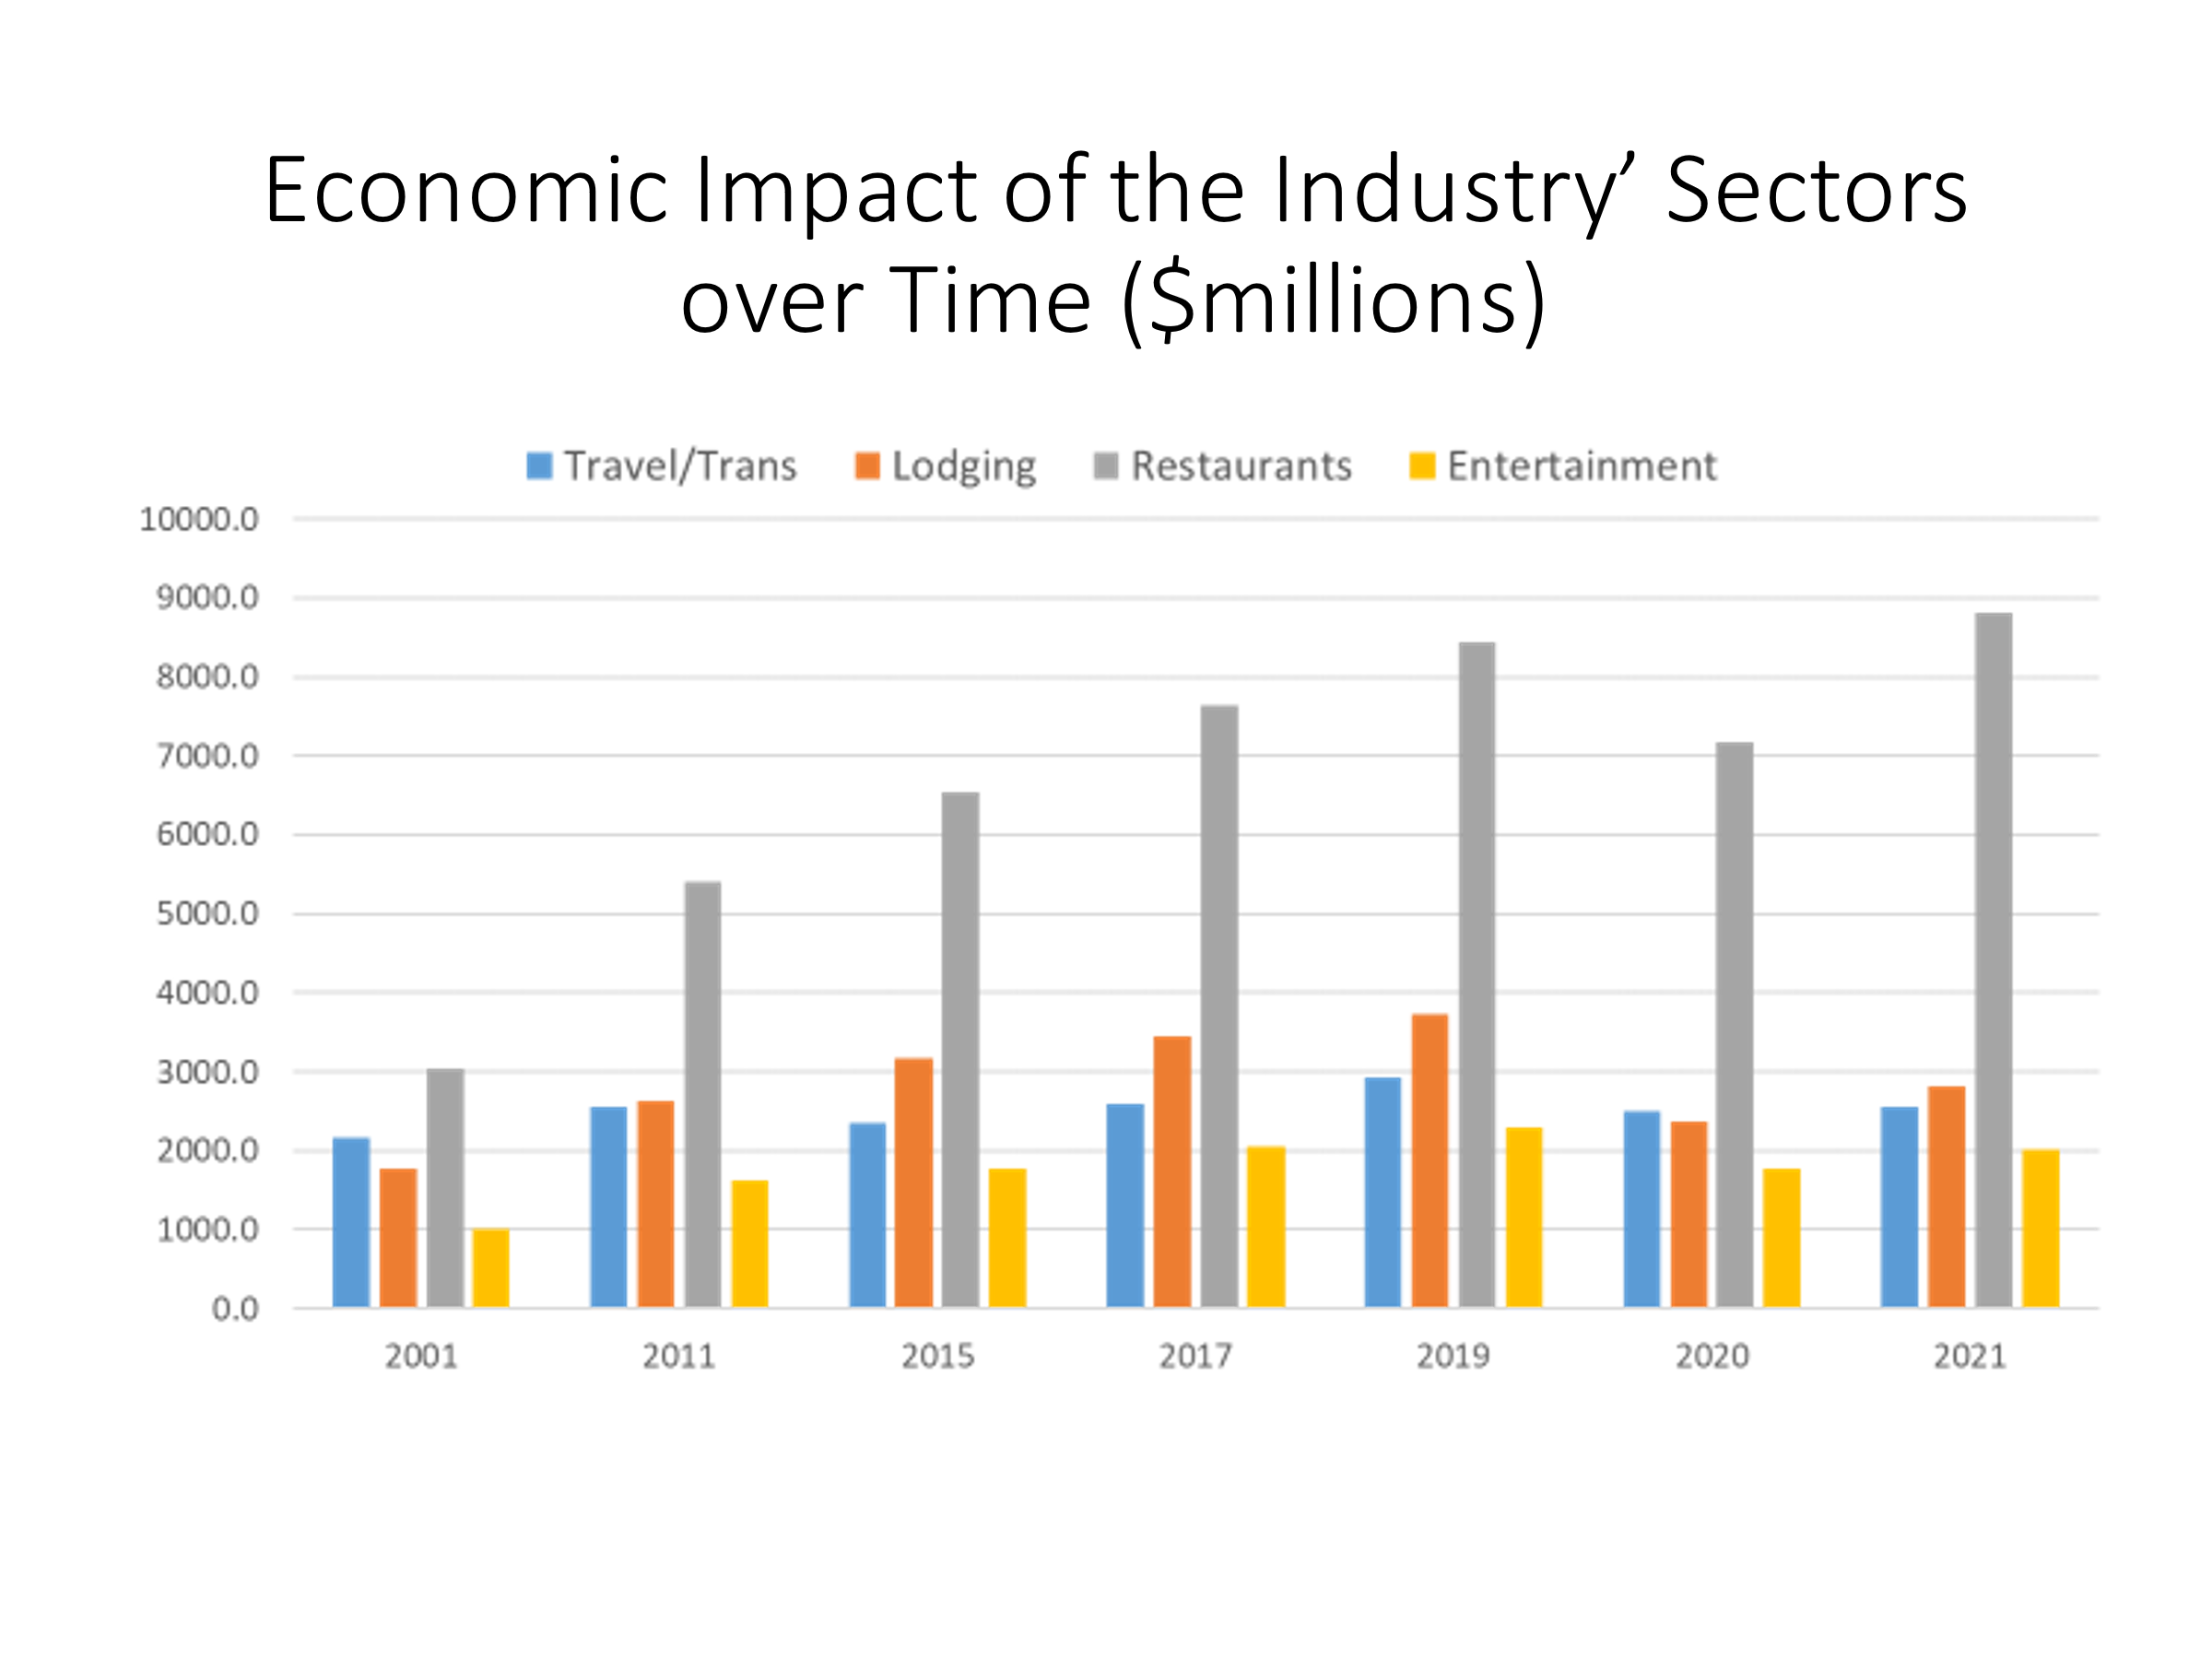FINANCIAL CONTRIBUTIONS TO LOCAL GOVERNMENT

The Hospitality Industry is a major contributor of tax and other revenues to local governments. A complete accounting of these contributions is beyond the scope of this study, but an examination of the major revenue streams for the City of San Antonio shows the extent to which local government depends upon the Hospitality Industry for financial support.

The bottom line for the City is impressive, as the Hospitality Industry provided revenues of $229 million in 2021. This is equivalent to 18% of the City’s adopted General Fund expenditure budget of $1.29 billion for the 2020-21 fiscal year.

These revenues come from a variety of sources. The largest share ($72.3 million) comes from the Hotel Occupancy Tax (HOT). Property taxes on real and personal business property accounted for $67.1 million (wow…this number is considerably higher from 2019 which was $42.1M…please confirm. in City revenues. City sales taxes paid on purchases at businesses in the Hospitality Industry contributed another $48.1 million (this number is much lower than 2019 number at $66.5M…please confirm. These businesses bought $102 million worth of electricity and natural gas from CPS Energy; since 13% of CPS revenues are paid to the City in lieu of taxes, the City received $13.3 million from these payments. Smaller amounts of revenue ($28.5 million in all) were received from Tourism Public Improvement District assessment revenues, river cruise and Tower of the Americas concessions as well as taxes on alcoholic beverages sold in restaurants and bars.

Let’s verify property and sales tax numbers and ensure chart below is accurate.

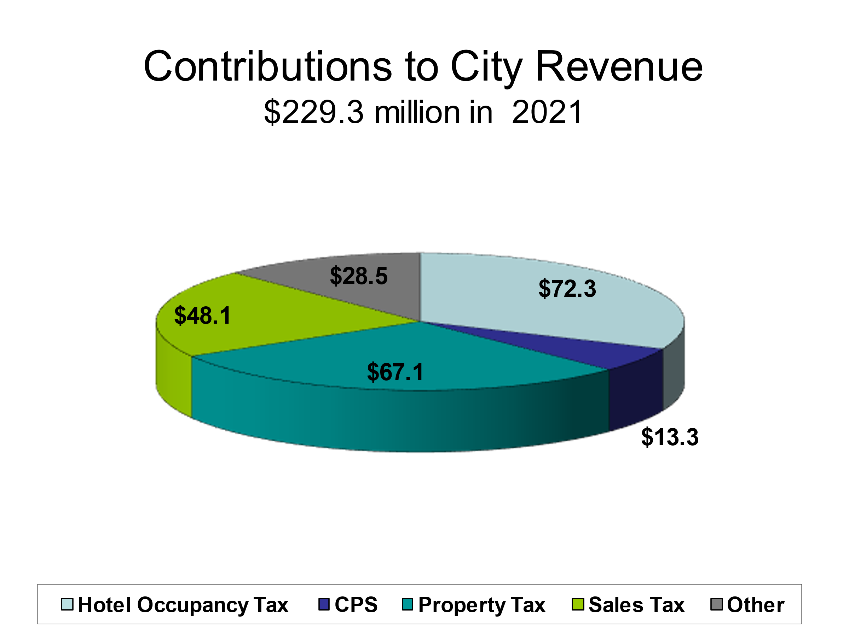

The City of San Antonio is not the only local government entity that depends on revenues from the Hospitality Industry. The industry pays sales, property, and hotel occupancy taxes to other municipalities. In addition, Bexar County collects property and hotel occupancy taxes, while school districts, the Alamo Community College District, the University Health System, and the San Antonio River Authority all levy property taxes paid by Hospitality Industry businesses. These businesses also collect sales taxes to support VIA Metropolitan Transit and the Advanced Transportation District.

These are not small sums. The County collected $14.1 million in HOT taxes and $10.7 million in rental car taxes in 2019. Property taxes on just those hospitality-related businesses located within the San Antonio city limits contributed $155.8 million to local school districts, $36.1 million to Bexar County and another $53.4 million to the other taxing entities. VIA and ATD sales tax revenues from Hospitality Industry businesses within the San Antonio city limits totaled $28.9million. In all, these local governments received $299 million, not including the sales and property taxes paid to entities outside the City limits.

The government revenues itemized above add up to approximately $528 million. Since this estimate excludes some property, sales and hotel taxes paid by hospitality-related businesses outside the San Antonio city limits, the full contribution of the industry to local government is in fact significantly greater than this estimate.

These revenues help reduce the taxes paid by those who live in the San Antonio metropolitan area. Without the tax payments from the hospitality industry, the city, county, and state would either have to reduce services or find additional resources to balance their respective budgets.

Not surprisingly, these revenues decreased significantly in 2020. Hotel taxes dropped by more than half, sales taxes decreased by 25%, and other revenues were also adversely affected. San Antonio’s receipts fell to $153.9 million, while the other entities received $184.6 million. These are still quite substantial sums, especially welcome during a time when all levels of government were under serious financial stress. These revenues rebounded significantly in 2021, especially property taxes. The City of San Antonio, for example, received 71% more property tax revenue from Hospitality businesses in 2021 than in 2020. Indeed, the 2021 revenues in 2021 were 60% higher than those in 2019, the last “normal” year.

Would you guys be to open to add this table in the bottom?

Happy to do that. But the Bexar County number in 2021 is $60.8, and the 2021 total is $528.2. (Already fixed.)

Entity Name | 2019 | 2020 | 2021
City of San Antonio | $247.4 | $153.9 | $229.3
Bexar County | $51.8 | $34.7 | $60.8
Property Tax School Districts | $102.6 | $89.8 | $155.8
Property Tax – other taxes entities | $33.5 | $30.1 | $53.4
VIA & ATD | $39.9 | $30.1 | $28.9
Total | $475.2 | $338.6 | $528.2

TECHNICAL NOTES

Information Sources for the Economic Impact Estimates

As noted in the introduction, the primary information source for this Economic Impact Study is the Texas Workforce Commission’s (TWC) Covered Employment and Wages database, which provides data on payroll and employment for the San Antonio Metropolitan Statistical Area aggregated into lines of business defined by the North American Industrial Classification System (NAICS) coding framework. It represents essentially a 100% sample of all the businesses in each NAICS code.

The specific industry codes used in this study are listed at the end of the Technical Notes section. The process of deciding which NAICS codes to include required some judgment. The study includes only those industries that derive a significant portion of their sales from out-of-town visitors, whether they are tourists, conventioneers, or business visitors. These businesses, not surprisingly, are concentrated in the lodging, eating, and drinking, transportation, and entertainment sectors. Clearly, San Antonio’s visitors patronize many other businesses, from department stores to gas stations. This spending would have to be included in an estimate of the overall impact of visitors on the San Antonio economy. But since this study is focused not on the impact of visitors but on the impact of the industry that serves visitors, the estimates presented here refer to the hospitality industry alone.

Since many of our visitors use air transportation to get here, it is entirely appropriate to include commercial air travel as part of the local Hospitality Industry. However, users of this study should be aware that passenger air service is also included in The San Antonio Chamber of Commerce’s economic impact study of the Aerospace Industry. This overlap is unavoidable since the commercial air travel sector is legitimately a part of both industries.

Information Sources for the Estimates of Financial Contributions to Local Government

Total revenues received in fiscal years 2019, 2020 and 2021:

Hotel occupancy taxes, river cruise fees, liquor taxes: Finance Department, City of San Antonio.
City General Fund Budget: Fiscal Year 2021 Adopted Budget, City of San Antonio website.

Estimates of 2019 and 2020 revenues for the Hospitality Industry NAICS codes only:
CPS revenues: CPS Energy.
Sales taxes: Texas State Comptroller’s Office.
Property taxes: Finance Department, City of San Antonio.

Information source for visitor statistics:

Annual studies of visitors to San Antonio, prepared for Visit San Antonio by D K Shiflett & Associates.
NAICS CODES FOR THE HOSPITALITY INDUSTRY

Transportation and Travel Arrangements

48111 Scheduled air transportation
48521 Interurban and rural bus transportation
48531 Taxi services
48551 Charter buses
48599 Other ground passenger transportation
48711 Scenic and sightseeing transportation
48811 Airport operations
53211 Passenger car rental and leasing
56152 Tour operators
56159 Other travel arrangement services
81293 Parking lots and garages

Lodging

7211 Hotels, motels, etc.
7212 RV parks and recreational camps

Restaurants, etc.

7223 Special food services
7224 Drinking places & Limited-service eating places
7225 Restaurants

Entertainment

51213 Motion picture exhibition
7111 Performing arts companies
71121 Spectator sports
7113 Promoters of performing arts
7115 Independent artists, writers, and performers
7121 Museums, historical sites, zoos, etc.
71311 Amusement and theme parks
71312 Amusement arcades
71391 Golf courses and country clubs
71399 Other amusement and recreation

